Amrita Kumari 6362289
WEEK - 5 (Module - 5)
Yash Raj
SuperSet ID - (6364442)

Hands-On Exercises: Authentication and Authorization in ASP.NET Core Web API Microservices:

Question 1:
Implement JWT Authentication in ASP.NET Core Web API

Scenario: You are building a microservice that requires secure login. You need to implement JWT based authentication.

Steps:
- Create a new ASP.NET Core Web API project.
- Add a `User` model and a login endpoint.
- Generate a JWT token upon successful login.
- Secure an endpoint using `[Authorize]`.
Solution JwtAuthMicroservice directory:

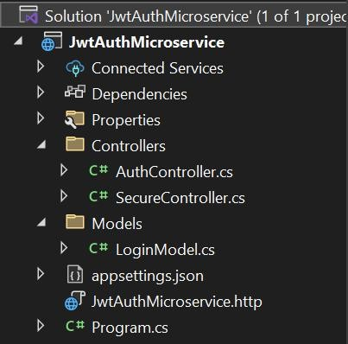

Sample Output
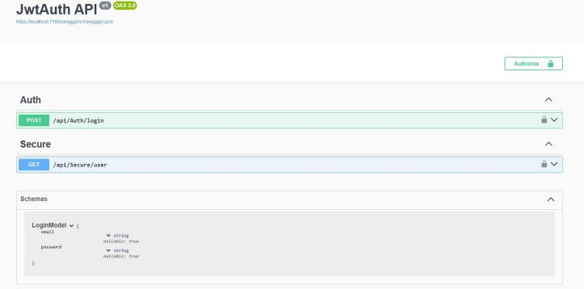

  - Login Endpoint
Endpoint: POST /api/Auth/login Request Body:
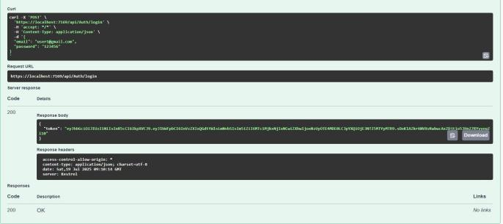

  - Access Secure Endpoint Endpoint: GET /api/Secure
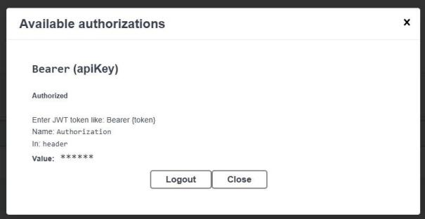
  - Endpoint: GET /api/Secure
